Animal Olympics
Vacation Bible School
God’s Amazing Creations
This Photo by Unknown Author is licensed under CC BY-SA-NC
S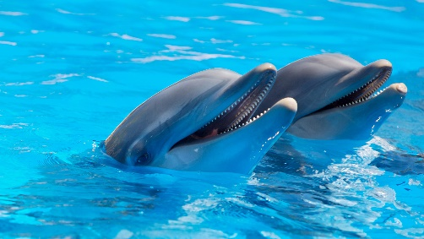 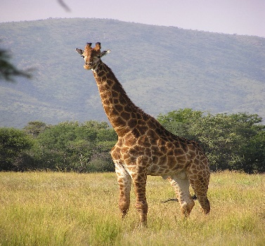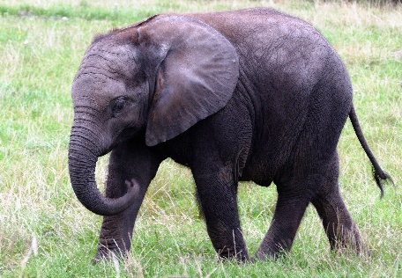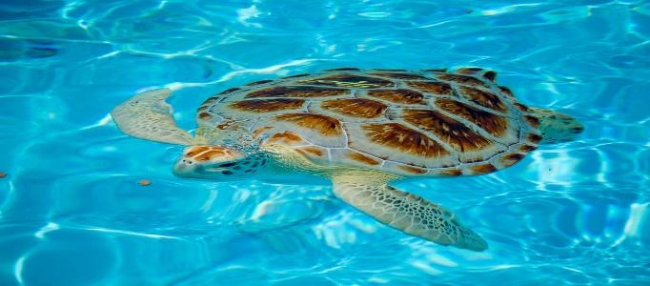 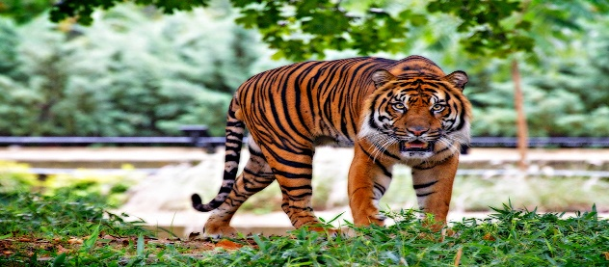
This Photo by Unknown Author is licensed under CC BY-SA
This Photo by Unknown Author is licensed under CC BY-SA
This Photo by Unknown Author is licensed under CC BY-SA
July 12th – July 16th
Pk- 5th Grade
9:00 am to 11:00 am daily
St. Joseph Church Hall
Contact Judy Koehnlein 740-537-4628 or judemarieknlein@hotmail.com

